IndiYatra — To Do
Task tracker for upcoming IndiYatra feature work.
- Mobile snippet player: tap-to-reveal card with swipe navigation
On mobile, redesign the snippet card so only the hook and image show by default (story-style cover). The hook is at the top and the image is below the hook. (the mock up shows the other way round). Tapping the card reveals a bottom sheet with the rest of the content - explanation, key term, life connection, refresher question, and citations. The sheet header (hook) stays pinned/sticky while its body scrolls independently for long content, using the same overflow-y: auto pattern already used for the comments sheet in SnippetPlayer.jsx. Swiping left or right still navigates to the next or previous snippet using the existing touch handlers, and re-collapses the sheet on navigation. Desktop keeps the current two-column layout.
The top navigation bar will continue in the current design. The bottom bar of the snippet which has like, comment, bookmark and share will also continue the same way. The edit button will also continue. The mockup does not properly represent these features. It only illustrates the tap to reveal other content.
Reference: interactive mockup approved in chat. Screenshots below.
Before tap — hook + image cover
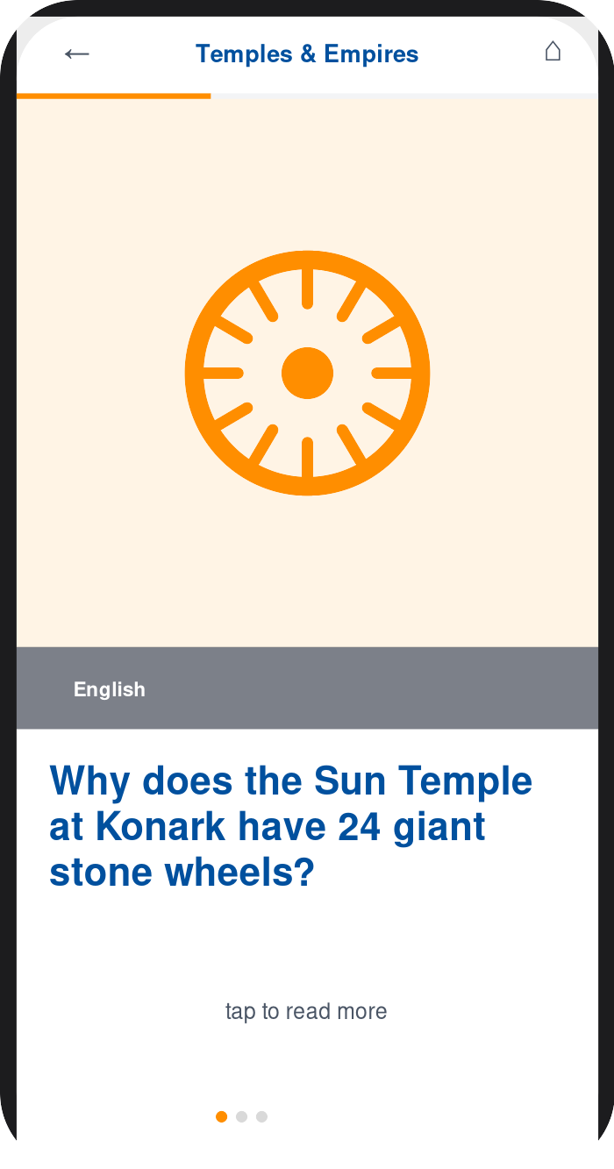
After tap — explanation sheet revealed
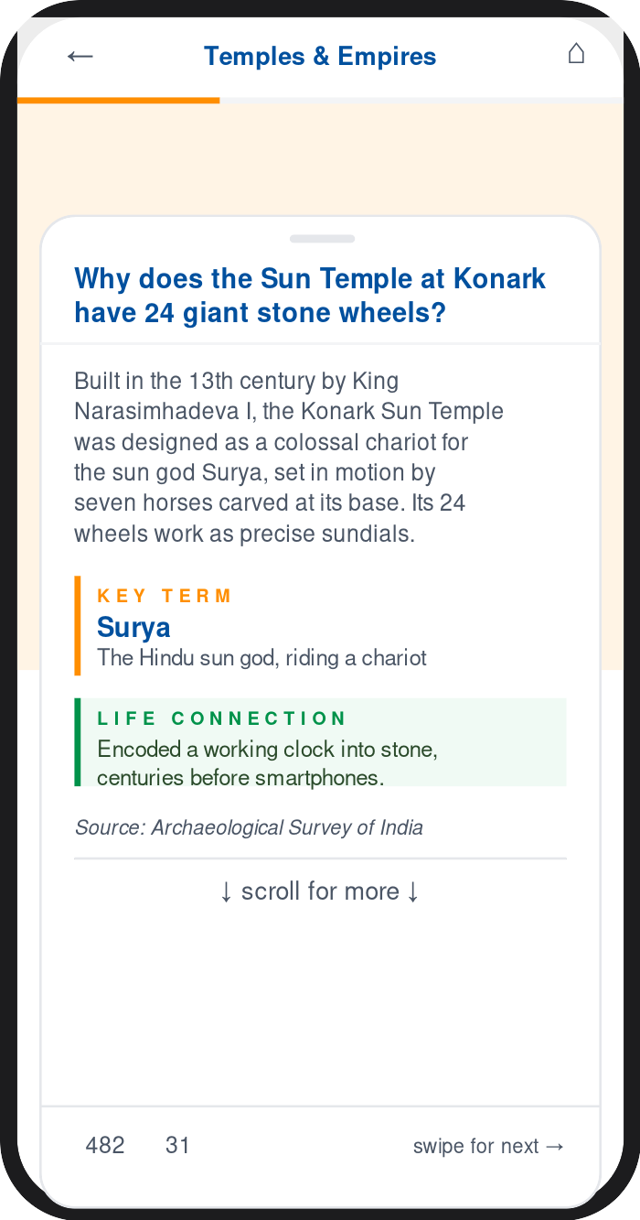
- Top and Bottom Nav Bars
Bottom Nav Bar. The bottom nav bar (standard across all screens except snippet player) will have Home, a new tab called “All Courses”, For You, Dashboard and Discover.
Top Nav Bar. The top Nav bar will have the IndiYatra logo on the left. It will have a set of three buttons on the right for Language Selection, Font Size Selection and Profile Settings. In the middle it will have the Resume button and depending on the user profile, the Admin and Edit Buttons

- All Courses: quick-commerce style category drawer for browsing the full content tree
The All Courses tab in the bottom nav bar functions like Zepto/Blinkit’s category drawer. Tapping it opens a two-pane screen: a left sidebar listing Courses, which expands inline to Levels, which expands inline to Themes (accordion behavior, one branch open at a time). All texts wrap when needed in the sidebar. Selecting a theme populates the main pane, split top and bottom. The top half shows that theme’s Modules as circular speedometer-gauge buttons — the gauge’s arc fill and color reflect % of lessons completed (gray under 25%, saffron 25–50%, heritage blue 51–75%, green above 75%), with the module name and “X lessons · Y stories” underneath. Tapping a module loads its Lessons as pill cards in the bottom half, each showing the lesson title plus two mini action buttons: Read (saffron, matching the Explore/Resume CTA color on the courses page) and Quiz (heritage blue, matching the existing quiz-recap color). Quiz button is disabled when no quiz is available.The modules pane and lessons pane scroll independently and vertically (each needs its own overflow-y: auto and min-height: 0 on all ancestor flex containers, plus overscroll-behavior: contain so a drag in one pane doesn’t bleed into the other or the sidebar).
Reference: interactive mockup approved in chat. Screenshot below. It shows the All Stories tab but it should read as All Courses. The top nav bar is not represented properly in the mockup. Use the standard top nav bar. The text All Courses + Course + Level + Theme should appear below the Top Nav bar in two lines in the same format as in the mockup. Use the teal colour from the brandbook for sidebar and lesson pill cards.
All Courses — course/level/theme drawer with module gauges and lesson actions
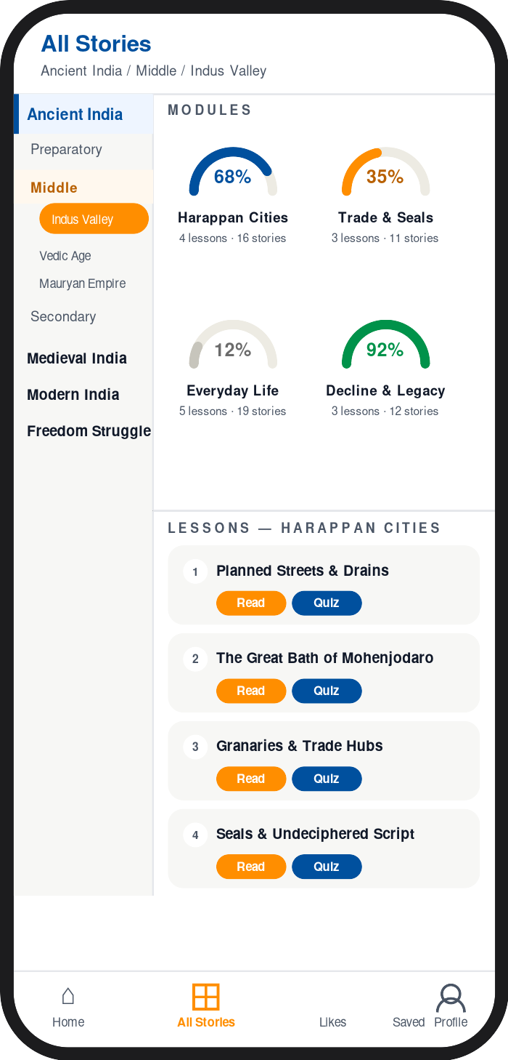

For You Screen — Sidebar Redesign + All Courses Integration
Redesign the mobile For You screen with two changes: (1) replace the current vertical scroll layout with a compact sidebar navigation, and (2) add an All Courses entry that replicates the All Courses drawer behaviour.

Change 1: Sidebar navigation
Replace the full-page scroll layout with a two-pane design. A narrow left sidebar (≈88 px) holds round icon-and-label buttons for every existing block. The main panel to the right shows only the content for the selected button. One button is active (highlighted) at a time.
Sidebar buttons (top to bottom):
- Resume — shows the Resume Yatra progress card in the main panel
- All Courses – add an All Courses button just below Resume (detailed after this bullet list)
- Based on Your Interest — shows the personalised recommendations rail
- Most Liked — shows the most-liked lessons carousel
- Most Bookmarked — shows the most-saved lessons carousel
- My Likes — shows the user’s liked snippets and Play All button
- My Bookmarks — shows the user’s bookmarked lessons and snippets

Change 2: All Courses button
Add an All Courses button below the Resume button in the sidebar. Tapping it highlights the button in heritage blue and expands a course tree inline beneath it. It behaves the same way as clicking the All Stories button in the bottom nav menu. (Course → Levels accordion → Themes). Selecting a theme populates the main panel with:
- Module progress — speedometer-arc gauge buttons for each module. Arc colour encodes progress: grey (0%), saffron (1–49%), heritage blue (50–74%), green (75%+). Tapping a gauge loads that module’s lessons below.
- Lesson list — each lesson row shows its completion state plus two action buttons: Read (saffron, opens the snippet player) and Quiz (heritage blue, opens the quiz). Quiz button is disabled when no quiz is available.
Reference: interactive mockup saved as ForYou_Redesign_Mockup.html. Screen captures below. The mockup does not represent the top nav menu and the bottom nav menu; and these continue as before
Screen 1 — For You sidebar, Resume selected
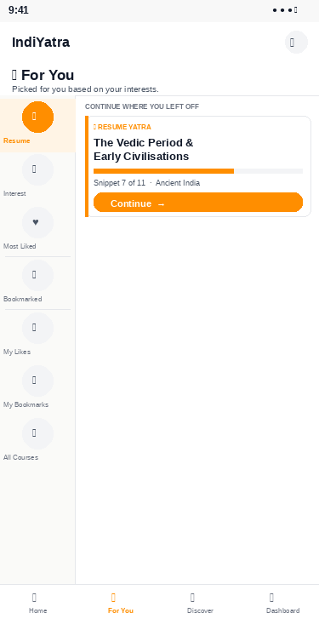
Screen 2 — All Courses selected, Ancient India theme expanded
